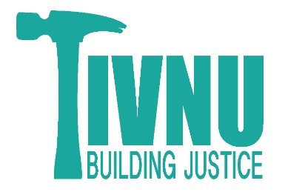
Reference Form for Tivnu: Building Justice Gap Year Program

Please submit completed reference forms to Leanna@Tivnu.org. Thank you for your candor and your time.

Name of Gap Year Applicant:
Name of Reference:
Job title of Reference:
Reference email address:
Reference phone number:
How do you know the candidate?
How long have you known the candidate?

Thank you for sharing your thoughts about this candidate with us at Tivnu: Building Justice. We appreciate your insights into who they are, what they can contribute to Tivnu, and what they might gain from the program. We will keep your comments in confidence.

Please read this description of the Tivnu Gap Year Program to get a sense of the skills and qualities of an ideal candidate before answering the questions below about the candidate in question. If you have any questions about the program please email Leanna@Tivnu.org.

The Tivnu Gap Year Program is a 9-month immersive program in Jewish social justice work. Participants are 17-20 years old and come from all over the country and abroad to live together in a home in Portland, Oregon. They work together to build a community in that home, sharing cooking and cleaning responsibilities, as well as celebrations and programming. Participants are housed in doubles and triples, so they also learn communication and communal living skills.
Tivnu participants spend most days interning at grassroots organizations in Portland, teaching, advocating for refugees’ rights, growing food with kids, building tiny houses, cooking for houseless Portlanders, and doing other meaningful work. We expect them to get to these internships consistently and on time and be conscientious workers while they are there. They work at their internships through the 9 months of the program, growing in skills and responsibilities as they build relationships and knowledge at their workplaces.
Tivnu also includes educational explorations twice a week, where participants learn from and with academics, activists, and individuals with personal experience in the social justice issues being examined. Each issue, from poverty to racial justice to labor and immigration, is examined in both a Jewish and global context.
Finally, the Tivnu Gap Year takes advantage of the beautiful Pacific Northwest setting to hike, camp, raft, and explore.

In what ways do you think this candidate’s strengths would shine at Tivnu? How might they contribute to the program? In what ways do you think Tivnu would be a good fit for this candidate?

Which aspects of the Tivnu program do you think would be most challenging to this candidate? In what areas do you think the candidate will have the most potential for growth? What might they gain from this gap year program?

Tell us about a time this candidate struggled with something and how they handled that struggle. This might be an academic, social, or other challenge.

What else do you think we should know about this candidate? What is something special about them that we might not otherwise know from their application?

Signature of Reference: ___________________________________________

